

**Overview of Capital Budgeting and Project Analysis**

**Fundamentals of Capital Budgeting**

* **Capital Budget:** Lists the potential investments that a company plans to undertake.
* **Capital Budgeting:** Process to analyze alternative investments focusing on their effect on the firm's cash flows.
* **Incremental Earnings:** Change in earnings due to the investment decision.
* **Core principle:** The central decision-making tool is the analysis of incremental cash flows, discounting them to find the project's net present value (NPV).
* **Capital Budgeting Process (steps)**
  1. Forecast revenues and costs.
  2. Calc incremental earnings.
  3. Calc free cash flow (FCF).
  4. Discount FCFs to find Net Present Value (NPV).
  5. Choose the bese alternatives based on NPV and other criteria.
* **Free Cash Flow Calculation:**

|  |
| --- |
| **FCF = Unlevered Net Income + Depreciation − Capital Expenditures − ΔNet Working Capital** |

* **Capital Budgeting**

**\*\*Discount cash flows, not profits.**

* Always discount actual cash flows, not accounting profits, because accounting earnings include non-cash items like depreciation.
* For example, a project with high returns but negative cash flow may cause liquidity problems.
* Working capital changes affect cash flow timing and must be accounted for separately from income recognition

|  |
| --- |
| **WC = Current Assets - Current Liabilities** |

Includes: Cash, inventory, receivables (money owed by customers), and payables (money owed to suppliers).

**Change in WC (ΔWC):** Directly impacts a project's cash flow timing.

* **ΔNWC > 0:** Cash outflow (cash flow dec) (e.g., more inventory bought, clients did not pay yet).
* **ΔNWC < 0:** Cash inflow (cash flow inc) (e.g., suppliers extend payment terms, receive).

**\*\*Discount incremental cash flows.**

|  |
| --- |
| **Incremental Cash Flow = Δrevenue – Δcosts – ΔNWC + Salvage − Opportunity Costs** |

The value of a project depends on all the additional cash flows that follow from project acceptance.

* Include all incidental effects (yếu tố phụ): Introduction of a new product will almost certainly cut into sales of existing products (Product Cannibalization – cạnh tranh nội bộ).

Ví dụ: Nếu công ty bạn ra mắt iPhone mới, một số khách hàng sẽ chuyển từ iPhone cũ sang mới → Doanh thu iPhone cũ giảm → Cần trừ phần doanh thu mất đi này khi tính dòng tiền gia tăng.

* Do not confuse average payoffs with incremental payoffs: The project has low average returns but the incremental returns can be high.Forecast product sales but also recognize after-sales cash flows.

Ví dụ: Mở rộng nhà máy hiện tại có thể rẻ hơn xây mới, dù lợi nhuận trung bình thấp.

* Forecast product sales but also recognize after-sales cash flows.

Ví dụ: Bán máy in → Tính thêm doanh thu từ mực in định kỳ.

* Include opportunity costs.

Ví dụ: Dùng đất xây nhà máy thay vì cho thuê → Chi phí cơ hội là tiền thuê mất đi.

* Forget sunk costs: Is a cost that has been incurred and cannot be recovered, does not affect future decisions.

Ví dụ: Chi phí nghiên cứu thị trường đã trả trước đó.

* Beware of allocated overhead costs: In investment appraisal (đánh giá), we should include only the extra expenses that would result from the project.

Ví dụ: Tiền điện tăng thêm do chạy máy mới → Tính. (variable cost)

Lương CEO → Không tính (vì là chi phí cố định). (fixed cost)

* Remember salvage value (gtri thanh lí): When the project comes to an end, you may be able to sell the plant and equipment or redeploy (triển khai lại) the assets elsewhere in the business.

Ví dụ: Bán thiết bị cũ thu về $50,000 → Cộng vào dòng tiền năm cuối.

**\*\*Treat inflation consistently:**

* + Real cash flow → Real rate
  + Nominal cash flow → Nominal rate
* Two approaches yield the same NPV: discount real cash flows at real rate or convert to nominal and discount at nominal rate

\*\***Separate investment and financing decisions.**

* **Separation Principle**: When securities are fairly priced, the NPV of financing is zero, and so the NPV of an investment is independent of how it is financed.
* Đánh giá dự án dựa trên khả năng sinh lời của bản thân nó, không phụ thuộc vào cách thức tài trợ (vay hay dùng vốn chủ sở hữu).
* Chi phí vốn (cost of capital) đã phản ánh rủi ro của dự án và cấu trúc vốn, nên không cần xem xét riêng các yếu tố tài chính.

**\*\*Forecast and deduct taxes.**

* Taxes are an expense just like wages and raw materials.
* Therefore, cash flows should be estimated on an after-tax basis.
* Subtract cash outflows for taxes from pretax cash flows and discount the net amount.
* Thuế ảnh hưởng trực tiếp đến dòng tiền của dự án (ví dụ: khấu hao giúp giảm thuế phải nộp).
* Cần tính toán dòng tiền sau thuế (after-tax cash flows) để phản ánh chính xác lợi ích của dự án.

**\*\*Incremental Earnings Forecast for DiagnosTech**

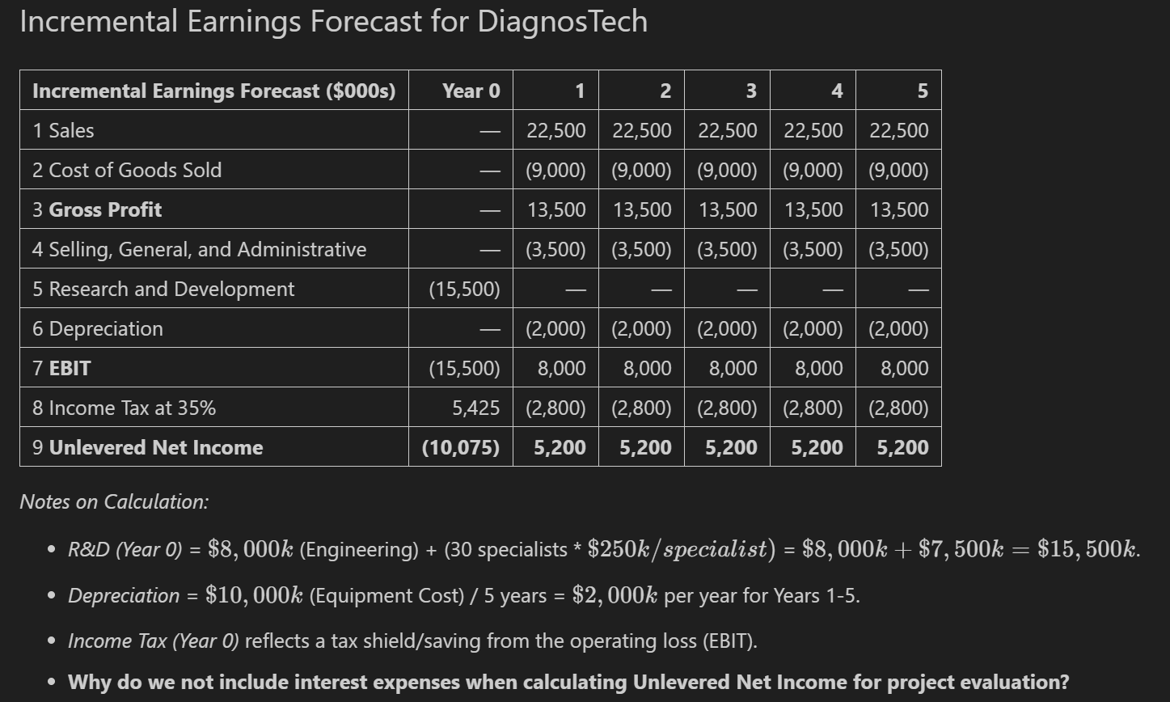

**\*\*Indirect Effects on Incremental Earnings**

* Opportunity costs (e.g., leasing lab space) and cannibalization (loss of sales from existing products) reduce incremental earnings.
* Sunk costs:
* Fixed overhead expenses
* Past research and development expenditures
* Unavoidable competitive effects
* Are excluded from incremental earnings.
* Adjusted unlevered net income reflects all these factors.

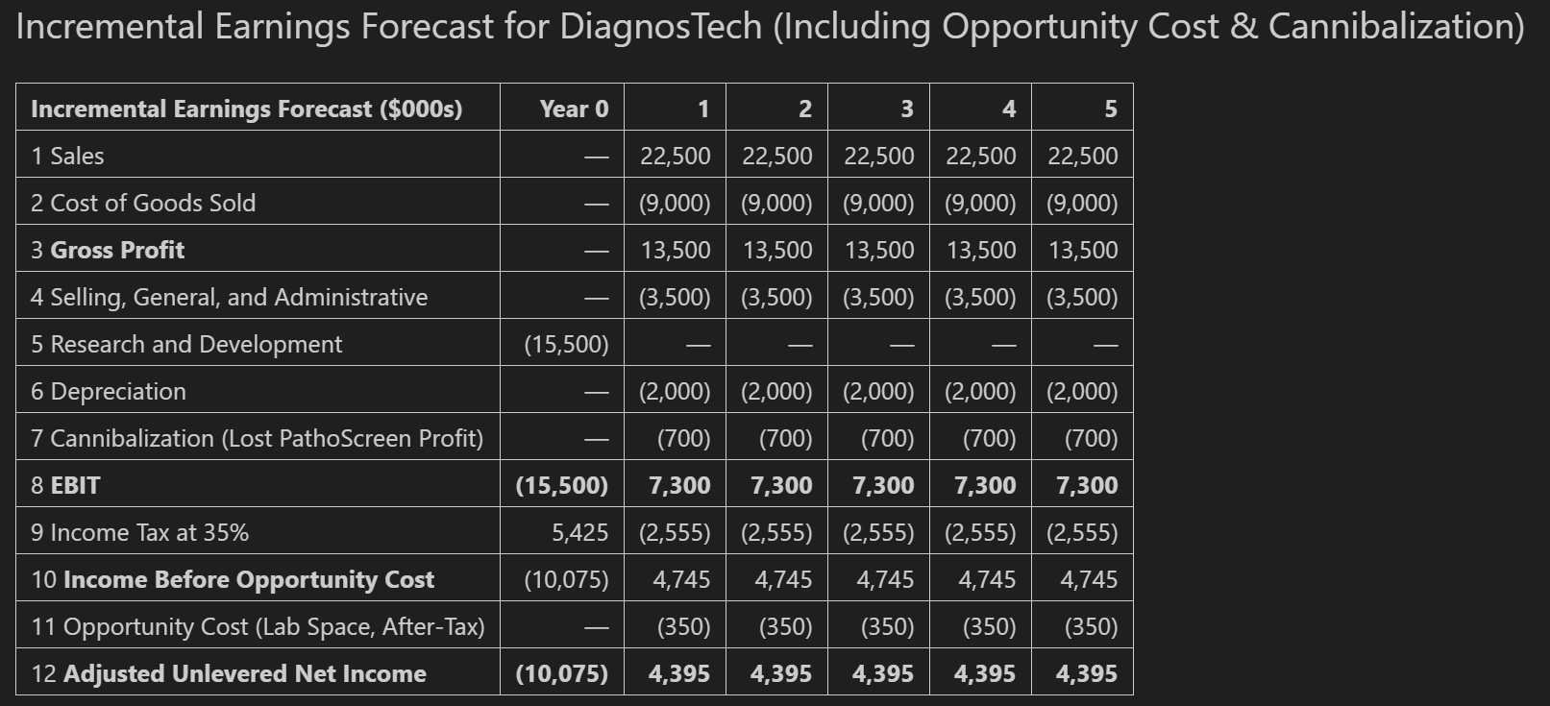

**\*\*Real – world externalities**

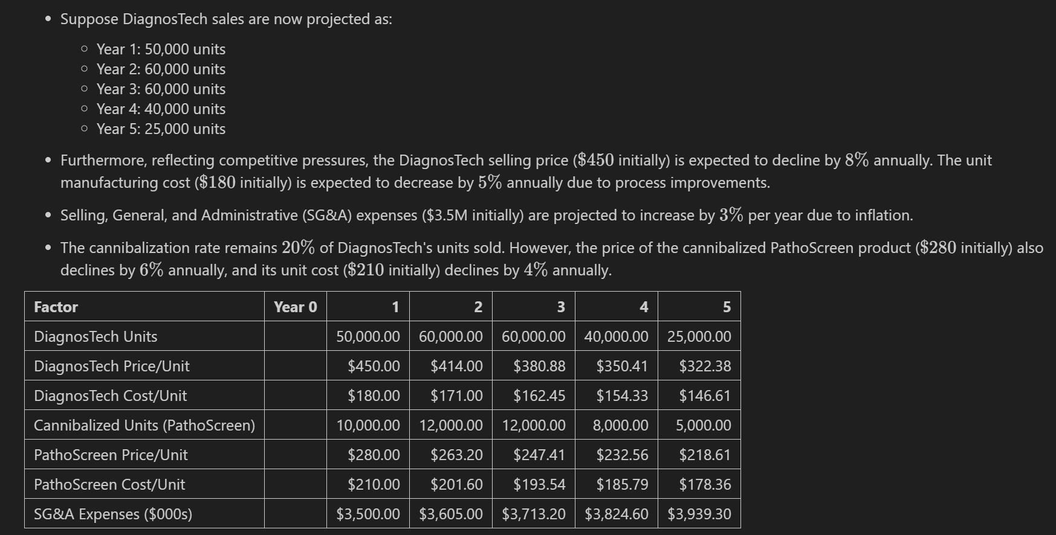

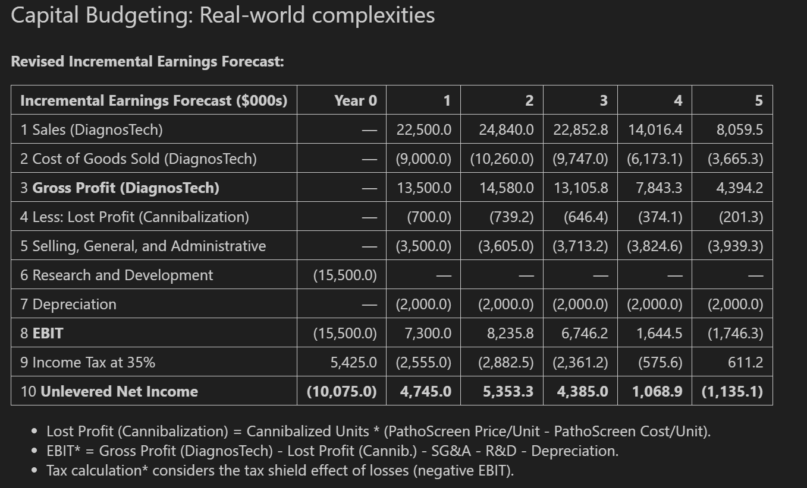

**Determining Free Cash Flow and NPV**

* Earnings (like Net Income) include things that don’t involve real cash, such as depreciation.
* But when we want to know how much cash a project actually generates, we look at Free Cash Flow (FCF) — this tells us how much money the company really has to use or return to investors.
* FCF calculation starts with Unlevered Net Income (UNI) and adjusts for non-cash expenses and cash flows related to investments.
* Add back non-cash expenses (like depreciation).
* Subtract capital expenditures (CAPEX).
* Subtract "increases in net working capital (NWC) or add decreases in NWC.
* Most projects require investments in Net Working Capital (NWC) to support operations.
* NWC represents the difference between short-term assets and short-term liabilities needed for the project.
* You need **more NWC** when your business grows (more products, more credit to customers), which uses cash. At the end of the project, you **recover that NWC**, and it adds to your final year’s FCF.

|  |
| --- |
| **NWC = (Cash required + Inventory + Receivables) – (Payables)** |

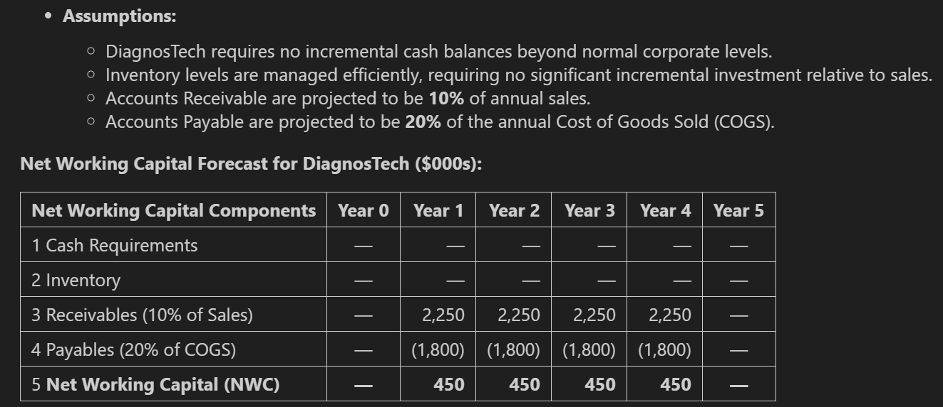

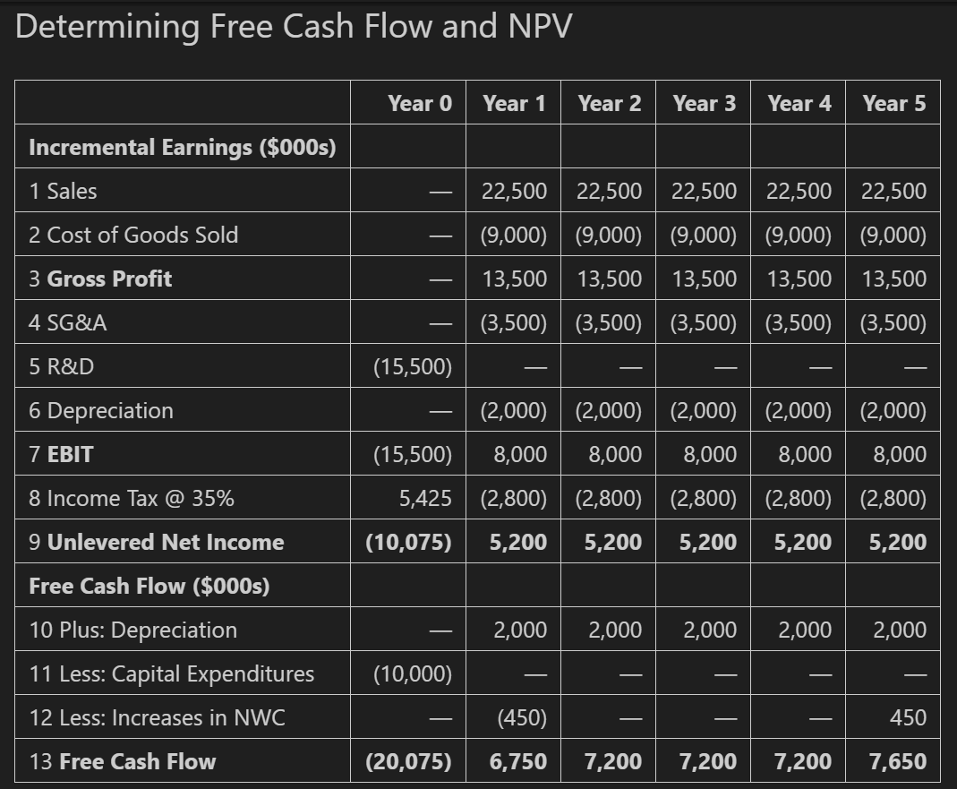

* The final step is to determine the project's value by **calculating the Net Present Value (NPV)**. This involves discounting the project's Free Cash Flows (FCFs) back to the present using the appropriate project cost of capital.

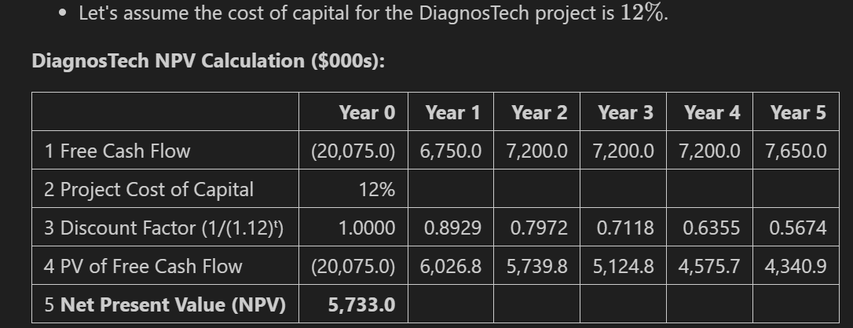

**Formulas Used to Calculate Free Cash Flow – PV**

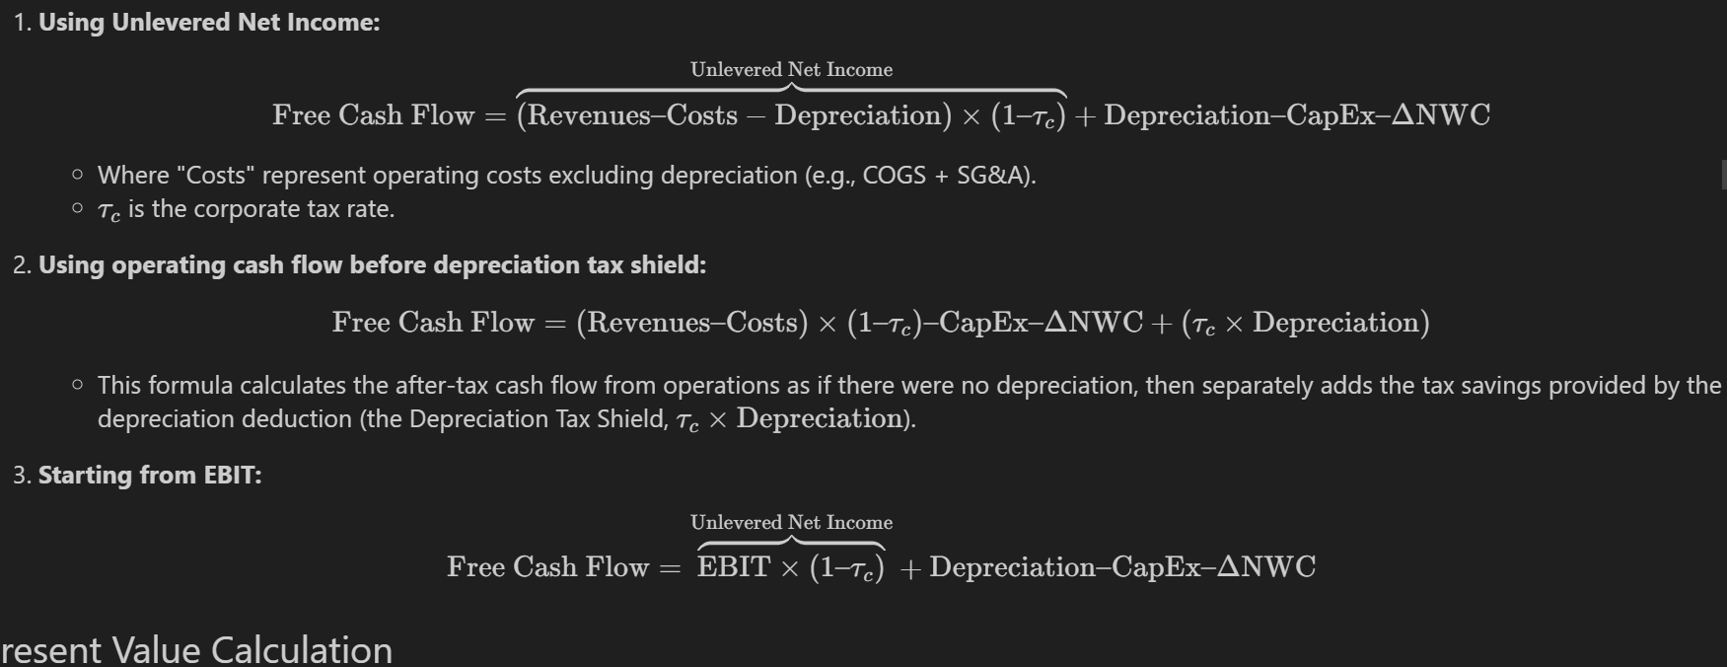

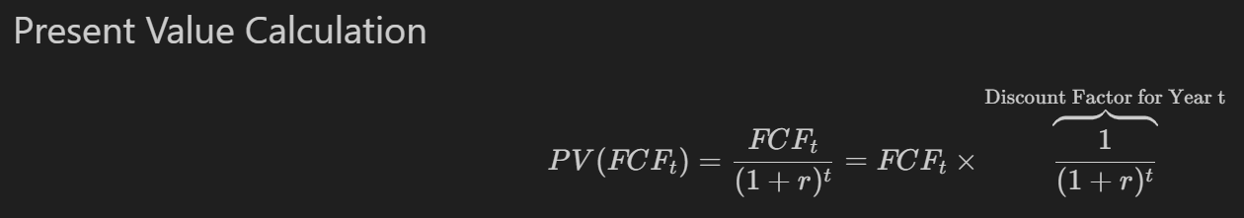

**Formulas Used to Calculate Operationg Cash Flow**





**\*\* In case CapEx = 0 and change in NWC = 0 => FCF = OCF**

**Further Adjustments to Free Cash Flow**

* **Other non-cash items**

In addition to depreciation, there are other non-cash expenses such as amortization of intangible assets (e.g. royalties, licenses). Since these are not real cash flows, we add these back to after-tax profit when calculating FCF.

* **Timing of cash flows**

Cash flows may occur quarterly or monthly, rather than at the end of each year. In this case, discounting needs to be adjusted to appropriate time points (e.g. using mid-year discounting or breaking down cash flows by quarter/month).

* **Accelerated depreciation (khấu hao nhanh)**

If the company uses accelerated depreciation, depreciation expense will be higher in the early years. This reduces taxes payable early, thereby increasing net cash flow earlier

➡️ Effect: Because cash flow is higher early, the present value (PV) of the project also increases, because money coming in earlier is worth more.

* **Liquidation or salvage value (Giá trị thanh lý / Giá trị còn lại của tài sản)**

At the end of a project's life, you might sell equipment or assets. The sale may result in a gain or loss compared to the asset’s book value.

|  |
| --- |
| **Book Value** = Original cost – Accumulated depreciation |
| **Gain on Sale** = Sale price/market value – Book value |
| **After-tax Cash Flow** from the sale = Sale price − (Tax × Gain on Sale) |

➡️ This after-tax cash flow is **added to the final year’s FCF**.

* **Terminal or continuation value (Giá trị tiếp tục)**

If the project is expected to continue to be profitable beyond the forecast period (e.g., after 5th year ), we estimate a terminal value that represents all future cash flows thereafter.

|  |
| --- |
| **TV =** |

* Tax carryforwards and carrybacks

**Analyzing the Project**

* **Break-even analysis**

**NPV Break – even**

* Determines the minimum level of sales/output needed for NPV = 0
* Calculation: Find the quantity where PV(inflows) = PV(outflows)

**IRR break-even**

* IRR is the discount rate that makes NPV = 0
* If project IRR > cost of capital, project is acceptable
* Break-even occurs when IRR = cost of capital

**EBIT break-even**

* Calculates the minimum EBIT needed to cover all costs

|  |
| --- |
|  |

* **Sensitivity analysis**
* Tests how NPV changes when varying one key assumption at a time:
* Common variables tested:

Sales volume (±10%, ±20%)  
Material costs  
Project lifespan  
Discount rate

* Allows us to explore the effects of variations in our NPV estimates for the project.
* **Scenario analysis**
* Examines how NPV changes under multiple simultaneous changes:
* Common scenarios:

Base case (expected outcomes)Best case (optimistic assumptions)Worst case (pessimistic assumptions)

* May include:

Economic recession scenario  
New competitor entry scenario  
Supply chain disruption scenario  
More comprehensive than sensitivity analysis as it captures variable interactions

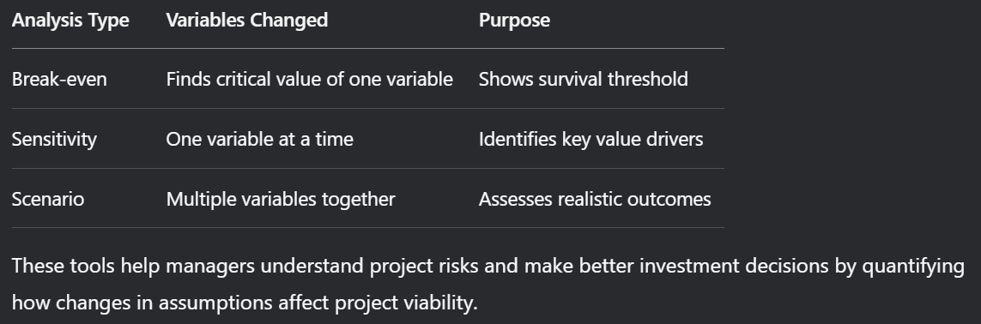

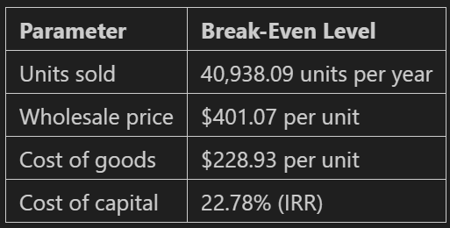

**1. Phân tích hòa vốn:**

* Sản lượng tối thiểu: **40,938 đơn vị/năm** (thấp hơn dự báo 50,000)
* Giá bán tối thiểu: **$401.07/đơn vị**
* Chi phí tối đa: **$228.93/đơn vị**
* IRR hòa vốn: **22.78%**

**2. Độ nhạy chính:**

* Nhạy nhất với **giá bán**: NPV giảm từ $5.73M xuống -$17.7M nếu giá giảm từ $450 xuống $250
* Sản lượng giảm 40% → NPV âm $6.92M
* Chi phí tăng 66% → NPV âm $8.33M

**3. Kịch bản chính:**

* Cơ sở: NPV $5.73M
* Xấu nhất: NPV -$25M (giá $250 + chi phí $300)
* Tốt nhất: NPV $20.38M (giá $575 + chi phí $120)

**Kết luận:**  
Dự án khả thi với biên an toàn tốt, nhưng cần kiểm soát chặt:  
✓ Duy trì giá bán > $400  
✓ Đảm bảo sản lượng > 41,000 đơn vị/năm  
✓ Kiểm soát chi phí sản xuất < $230/đơn vị

→ **Nên đầu tư** nhưng cần theo dõi sát các rủi ro về giá và chi phí.

New chat